Falkirk Christmas Trees 2025
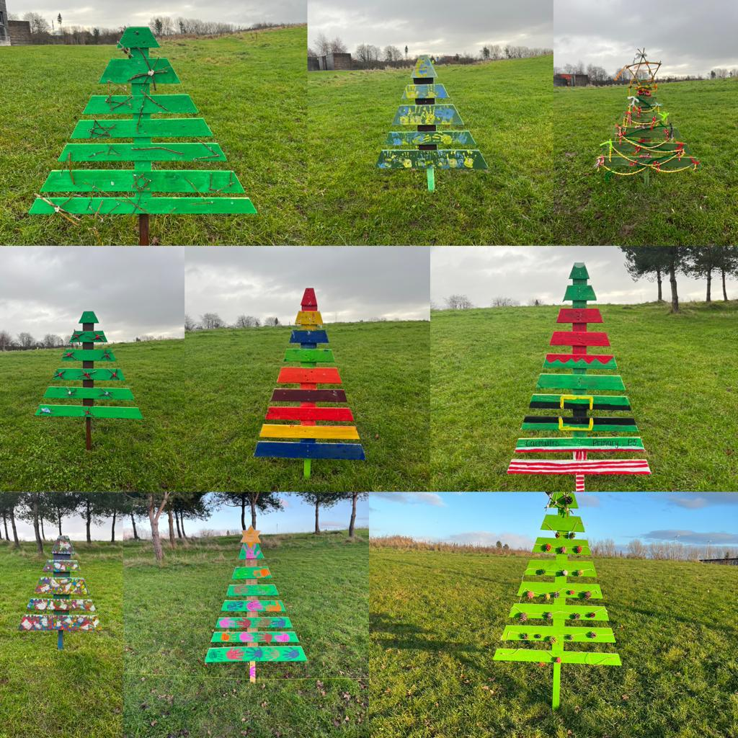

Introduction

In cities all around the world, festive tree displays are a highlight of the season. Beautiful and inspiring trees are created by designers who combine festive traditions and contemporary design.

This year, Falkirk Council are looking to commission one designer/maker to create a bespoke and unique ‘Christmas Tree’ as part of our Festive Celebrations

Concept

For two years we have displayed unique interpretations of ‘Christmas Trees’ made from reused and recycled wooden pallets as a festive celebration involving local primary schools and nursery groups at Helix Park. (see image at the top of the page as an example)

We are looking to develop this by inviting a designer /maker to design and work with community groups using the ‘Christmas Tree’ as the central focus and inspiration, but final designs can take any form. The designer will also produce 1 large tree of their own interpretation of ‘Christmas tree’

The ‘Trees’ will form part of a display located at Helix Park,

All final installations must represent the highest quality of design.

The project is seeking creative, unique designs which respond to the concept of a central Christmas Tree in festival celebrations. While the main inspiration for this brief is the Christmas Tree, we are looking for responses that celebrate the diversity of the winter period from different perspectives.

Considering the environmental impact of large-scale festivities and the commitment from the Falkirk area to celebrate our own living Christmas tree, this project focuses on the words reduce, reuse and recycle. All elements of the ‘tree’ and its decoration must be made from 100% reused or recycled materials.

We would be looking for one large tree and would again look to work with local primary schools and nurseries to continue their involvement using the pallet tree model which can be expanded to include more community groups across the district. Falkirk Council Events Team can assist with sourceing pallets and provide instructions on how these are constructed.

Eligibility

This opportunity is open to:
  - Designers and makers who live or work in Falkirk District area (defined as living or work address with a FK1 – FK6 & EH51 postcode)
  - Designers from Falkirk (defined as FK1 – FK6 & EH51postcode) and recent graduates

Award

One successful designer will be awarded £5,000 to cover all materials, production, installation, and fees. This must also include the installation of the pallet Christmas trees at Helix Park

Additional support in ensuring the trees are safely secured will be provided by the Falkirk Council Events Team.

Essential considerations

  - The large tree must be between 1.6m minimum and 2.5m maximum height.
  - All elements making up the tree and its decoration must be made from 100% reused or recycled materials.
  - If the design requires a real tree, you must demonstrate how sustainable this is. Single-use trees are not permitted.
  - The trees must be transportable and suitable to be stored.
  - There is no power supplied. The display area will have general floodlights for illumination of the trees unless it is not required by the designer. If the design includes lights, then details on how these are reused and sustainably powered must be provided.

  - The tree will have a brief explanatory text displayed which will tell the story of the design, its designer and context.
  - The ‘tree’ will be required to be secured to protect it from adverse weather. Falkirk Council events team will work with the selected designer/maker to ensure the structure is safe and conforms to Health & Safety requirements.
  - The trees will be situated outside in the elements of winter for seven weeks so the recycled materials selected must be able to withstand high winds, heavy rain, low temperatures, and potentially heavy snow.

Installation / de-install

  - The trees will be installed on the grass areas.
  - Exact location and positioning will be at the discretion of the Falkirk Council Events Team and cannot be negotiated.
  - Installation will be the responsibility of the designer/maker. This process will be supported by the Falkirk Council Events Team.
  - The trees must be installed on the morning of Friday 5th December and must be ready for public viewing by 3pm on the same day.
  - The trees will be dismantled on the 5th January 2026. The Falkirk Council Events Team will carry out this work. You will need to provide instructions regarding the dismantling.
.

Look and feel

The installations must be design-led, cool, contemporary, and eye-catching. They can be fun or edgy, or anywhere in between, if they uphold the highest qualities of design and are accessible to the audiences listed above.

Submission - How to apply
Submission is via the application form below, and must be completed by all applicants: INSERT LINK TO ONLINE FORM
- Deliverables – Elements to be delivered by the successful applicant to complete the project.

- Design, production and installation of a tree within dimensions between 1.6m minimum and 2.5m maximum height., though stability solutions such as guy ropes, wide bases etc may exceed this footprint.
- 50–100-word text outlining your inspiration for your design; 50–100-word biography, both for public display.

  - 300dpi JPG images of previous representative work in square, landscape and portrait format. We require clearance for promotional use for the project including but not limited to websites, social channels, events listing sites, on-site screens, and e-news.

Budget

£5,000 to cover all materials, production, installation, and fee.

Indicative Schedule

Activity | Date
Designer’s applications close | 1st October 2025
Designers awarded | 17th October 2025
Community group engagement start | 27th October 2025
Install | Friday 5th December 2025
Destall | Monday 5th January 2026

Intellectual Property

The organisers retain permission to use images of the installations with clearance for promotional and reporting use including but not limited to websites, social channels, events listing sites, on-site screens and e-news.

It is expected that images of the displays, and some design drawings or mockups may be used on social media and organisers’ websites, and for future promotion of the organisers’ activities.

The organisers will store the trees and retain permission to present the Trees in public for up to 5 years. Should the Trees require remedial work, or repair, this will be negotiated between Falkirk Council and the designer.

All intellectual property rights, computer files and paperwork remain the property of the designer.

The physical artworks and displays remain the property of the designer. They will be held in the care of Falkirk Council Events Team for a maximum period of 5 years at which point they will be returned to the designer, or further negotiation will be carried out.

Online application form

FALKIRK CHRISTMAS TREES Open Call
Thank you for your interest in designing a tree for Falkirk's Designer Christmas Trees.
Through this project, Falkirk Council Events Team, are looking for one designer/maker to create a bespoke, unique ‘Christmas Tree’ using recycled or disused materials.
DEADLINE: Applications close 22nd August 12 noon
Please get in touch with the events team if you have any questions or issues submitting your application.
Email events@falkirk.gov.uk
ELIGIBILITY
This opportunity is open to:
Designers and makers who live or work in Falkirk (defined as living or work address with a FK1 – FK6 & EH51 postcode)
Professional designers and recent graduates (graduating in the last 4 years) originally from or having studied in Falkirk (defined as FK1 – FK6 & EH51 postcode)
SELECTION CRITERIA
Applications will be scored using the following weightings.
Quality of design and how it meets brief: 40%
Relevant skills and experience: 40%
Credibility of installation plans: 20%
ABOUT THE APPLICATION
To help you plan your submission, please find all the questions below.
Applicant Details
1. Name of designer
2. Lead contact name
3. Contact address
4. Contact number
5. E-mail address
6. Website
7. Social media account and/or other website
Your Proposal Outline
8. Please give a brief summary of your tree design proposal, no more than 300 words. This is to help us understand your ideas and how they fit the brief. We may also use this in publicity and reporting to describe your project.
9. Please upload any outline sketches, mood boards and images to support your proposed design of your tree design including lighting option (PDF or other digital format).
Please ensure to label your file(s) with your name before you upload.
10. Materials - please outline your planned materials and their sources, bearing in mind the need to utilise reused and recycled materials.
11. Delivery proposal – please briefly outline your installation plans – will you pre-build, paint on site, subcontract help or other?
12. Please give indicative costings, to demonstrate that the project is achievable in the budget available to you?'
13. Removal – What will removal involve? Does the tree come apart in sections or break down? Outline any plans here.
Your Work History.
14. Please tell us about your previous works, detailing if they were public artworks and their audiences if that applies.
15. Please submit images from at least three previous works. These do not need to have been made public or displayed.
Please ensure to label the files with your name before you upload.
16. Please briefly summarise your creative career to date.

